Dust Masks are for general and landscape work. Not to be used around vapor-producing mists.

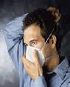
N95 is the most commonly used disposable particulate respirator. N stands for respirator filters that can be used when no oil is present in the contaminants

- Place respirator over your nose & mouth. Be sure the metal nose clip is on top
- Pull the bottom strap over your head until it rests at the back on your neck. If you have long hair make sure you lift your hair and the respirator strap is firmly against your neck
- Pull the top strap over your head until it rests on the crown of your head above your ears
- Using both hands starting at the top, mold your nose clip around your nose to achieve a secure seal (This step is mandated in the citations that were issued)
- When an N95 respirator is fitted properly, will prevent 95 percent of the particulate matter in the air from being inhaled by the user

Perform both a Positive Pressure Seal Check & a Negative Pressure Seal Check. User seal checking is a step in respirator training that users are trained to do each time they put on a respirator.

Check the seal of the mask to your face before each use. Put both hands completely over the front of the mask and take a quick, deep breath in and out (pictured left).
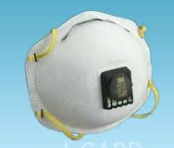
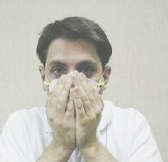
The mask is properly worn if no air escapes from the mask. It should slightly collapse when breathing in and slightly bulge when breathing out.
If you feel air blowing around your face or eyes, re-adjust the nosepiece and straps and check the seal again.
If the mask has an exhalation valve, check the seal by covering your hands over the mask and valve and breathe in sharply.
The mask is sealed if it collapses slightly and no air comes in around the edges.

If you feel air escaping, readjust the nosepiece & straps & test again until the mask is sealed
If you cannot achieve a secure seal, do not enter the contaminated area

N95 respirators are not manufactured in a way that they can be repaired. If any deficiencies are found in an N95 respirator, it should be discarded.

